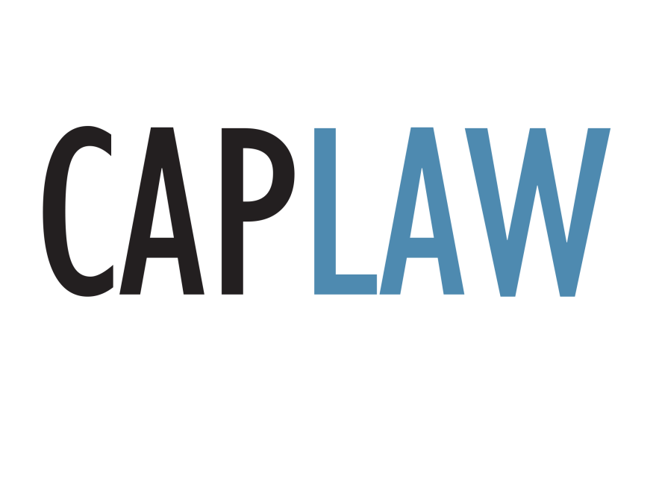

WORKING WITH SUBRECIPIENTS:
PRE-AWARD RISK ASSESSMENT TOOL

Last Updated July 2017

This subrecipient pre-award risk assessment tool was developed by Community Action Program Legal Services, Inc. (“CAPLAW”) and has not been approved by any outside authority, such as the U.S. Department of Health and Human Services. You should review this tool and the sample pre-award risk assessment questionnaire thoughtfully and modify it as necessary to meet the individual needs of your organization and to comply with any laws and regulations that apply to your organization’s particular situation, as well as the terms and conditions of the funding agreements covered by this subaward agreement. CAPLAW strongly recommends that when working with this sample pre-award risk assessment questionnaire, you consult with an attorney in your state who is well-versed in the laws affecting Community Action Agencies (CAAs) and applicable state law.

This sample pre-award risk assessment questionnaire contains bracketed text and footnotes corresponding to specific provisions, both of which are intended to help you better understand the questionnaire and how to adapt it to the needs of your organization. You should update this text and delete any brackets when finalizing the pre-award risk assessment questionnaire.

This publication is part of the Community Services Block Grant (CSBG) Legal Training and Technical Assistance (T/TA) Center. It was created by Community Action Program Legal Services, Inc. (CAPLAW) in the performance of the U.S. Department of Health and Human Services, Administration for Children and Families, Office of Community Services Cooperative Agreement – Grant Award Number 90ET0441-01. Any opinion, findings, conclusions, or recommendations expressed in this material are those of the author(s) and do not necessarily reflect the views of the U.S. Department of Health and Human Services, Administration for Children and Families.

Working with Subrecipients: Pre-Award Risk Assessment Tool

CAAs may, at times, decide to engage the services of another entity to assist the CAA in carrying out projects under its federal award. A CAA can do so by entering into subrecipient or contractor (vendor) relationships. This tool is intended to assist a CAA that is contemplating entering into a subaward agreement to pass through federal funds to a subrecipient. It describes the pre-award risk assessment that a CAA must conduct with respect to a subrecipient pursuant to the Uniform Administrative Requirements, Cost Principles, and Audit Requirements for Federal Awards, 2 C.F.R. Part 200 (the Uniform Guidance) prior to entering into a subaward agreement. Based on the results of the pre-award risk assessment, the CAA will enter into a subaward agreement that implements appropriate oversight and monitoring mechanisms to ensure that the subrecipient uses the funds for authorized purposes and in compliance with all applicable laws.

Subrecipient vs. Contractor

Because different rules govern the process by which a CAA selects a subrecipient or contractor and the level of oversight the CAA is required to perform, it is important to determine whether the party receiving the CAA’s federal funds is a subrecipient or a contractor. CAAs must evaluate each agreement on a case-by-case basis, and the Uniform Guidance provides a list of factors that describe each relationship. The substance of the relationship, however, is determinative, and CAAs should use judgment in classifying each agreement as a subaward or procurement contract, as not all characteristics listed below will be present in every relationship.

A subrecipient is an entity that receives a subaward from a pass-through entity to carry out part of a federal program (but does not include an individual who is a beneficiary of the program). Factors suggesting that the entity is a subrecipient include:
- the entity determines who is eligible to receive what federal assistance;
- the entity’s performance is measured in relation to whether objectives of a federal program were met;
- the entity has responsibility for programmatic decision making;
- the entity is responsible for adherence to applicable federal program requirements specified in the federal award; and
- in accordance with its agreement, the entity uses the federal funds to carry out a program for a public purpose specified in authorizing statute, as opposed to providing goods or services for the benefit of the pass-through entity.

Examples of subrecipients include: (i) a Head Start delegate agency that provides comprehensive Head Start child care programs to children in specific geographic areas; and (ii) a Title X family planning delegate agency that operates a community health center providing a full range of Title X family planning services in specific neighborhoods. If the CAA determines the entity to be a subrecipient, the CAA must conduct the pre-award risk assessment described in this tool prior to entering into a subaward agreement with the subrecipient.

A contractor, on the other hand, is an entity that has an agreement to provide a non-federal entity with property or services needed to carry out a project or program under a federal award. Factors suggesting that an entity is a contractor for goods or services include:
- the entity provides the goods and services within normal business operations;
- the entity provides similar goods or services to many different purchasers;
- the entity normally operates in a competitive environment;
- the entity provides goods or services that are ancillary to the operation of the federal program; and
- the entity is not subject to compliance requirements of the federal program as a result of the agreement, though similar requirements may apply for other reasons.

Common examples of contractors are entities or individuals providing design and maintenance services for a CAA’s website, Head Start food service, or training for the CAA’s employees. If the CAA determines the entity to be a contractor, the CAA must follow its procurement procedures and policy to select the contractor.

Pre-Award Risk Assessment
To determine whether to make a subaward and the appropriate level of monitoring to undertake if an award is made, the CAA must first evaluate each subrecipient’s risk of noncompliance with federal statutes, regulations, and the terms and conditions of the subaward. In doing so, the CAA will need to consider factors such as: (i) the subrecipient’s prior experience with the same or similar subawards; (ii) the results of previous audits; (iii) whether the subrecipient has new personnel or new or substantially changed systems; and (iv) if the subrecipient receives direct federal awards, the extent and results of the federal awarding agency’s monitoring process. A sample pre-award risk assessment questionnaire based on the requirements of the Uniform Guidance, 2 C.F.R. § 200.331, is provided in Exhibit A. CAAs should require that all potential subrecipients complete this questionnaire prior to entering into a subaward agreement.

Based upon the results of the pre-award risk assessment, CAAs should consider imposing specific subaward conditions upon a subrecipient, as appropriate. These additional subaward conditions may include items such as the following:

- Requiring payments as reimbursements rather than advance payments;
- Withholding authority to proceed to the next phase until receipt of evidence of acceptable performance within a given period of performance;
- Requiring additional, more detailed financial reports;
- Requiring additional project monitoring;
- Requiring the non-Federal entity to obtain technical or management assistance; or
- Establishing additional prior approvals.

If the CAA imposes additional subaward conditions, it must notify the subrecipient as to:
- The nature of the additional requirements;
- The reason why the additional requirements are being imposed;
- The nature of the action needed to remove the additional requirement, if applicable;
- The time allowed for completing the actions if applicable, and
- The method for requesting reconsideration of the additional requirements imposed.

Any specific conditions must be promptly removed once the conditions that prompted them have been corrected.

Monitoring a Subrecipient
At a minimum, all CAAs subawarding federal funds are required to conduct the following monitoring activities during their relationship with their subrecipients: (i) review financial and performance reports required under the subaward agreement; (ii) verify that an audit or other on-site review is being performed pursuant to the Uniform Guidance and that the subrecipient receives a Single Audit if expects to expend $750,000 or more in federal awards during its fiscal year; (iii) follow up to ensure that the subrecipient takes appropriate action on any audit findings and deficiencies; and (iv) issue a management decision on audit findings relating to the federal funds awarded to the subrecipient. Depending on the results of the initial risk assessment, CAAs may also need to provide subrecipients with on-site training and technical assistance on program-related matters, perform on-site reviews of the subrecipient’s program operations or arrange for agreed-upon procedures to monitor the subrecipient.

Terms and Conditions of the Subaward Agreement
As the recipient of the federal award, the CAA is solely responsible to the federal awarding agency for the execution of the award. Thus, when a CAA subawards its federal funds to a subrecipient, it is important that the subaward agreement allows the CAA to have effective contractual control over the subrecipient’s activities and gives the CAA legal remedies against the subrecipient. Under the Uniform Guidance, CAAs are required to monitor the activities of their subrecipients to ensure that subawards are used for authorized purposes and in compliance with applicable federal law and the terms and conditions of the subawards. A sample Subaward Agreement is available from CAPLAW for CAAs to use as a starting point. CAPLAW strongly recommends that when working with this sample pre-award risk assessment questionnaire or drafting a subaward agreement, a CAA consults with an attorney in its state who is well-versed in the laws affecting Community Action Agencies (CAAs) and applicable state law.
Exhibit A
Subrecipient Information and Pre-Award Risk Assessment Questionnaire

How to Use: This questionnaire is used to help determine a potential subrecipient’s financial and management strength, which helps assess risk and dictates the monitoring plan for subrecipients. This questionnaire must be completed prior to entering into a subaward agreement. The CAA may follow up with the potential subrecipient regarding the responses to this questionnaire.

- CAA Contact Information
Name of CAA Representative:
Project Name:
Grant Number:
- Subrecipient Contact Information
Full Legal Organization/Business Name:
Address:
Telephone number:
Fax number:
Name of person completing this form:
E-mail address:
Website:
Incorporated in: Incorporated Date:
Number of employees:
DUNS number:
EIN (Employee ID Number):
Fiscal Year (Month/Year):
- Subrecipient Type of Organization (select one):
Government |  | Nonprofit corporation |  |  |  | Other corporation |  |  | Individual
- Subrecipient Organization Classification (select all that apply):
Large Business |  |  |  |  |  | Small Business
Historically Black College/University |  |  |  |  |  | Small Disadvantaged Business
Historically Underutilized Business Zone |  |  |  |  |  | Woman-Owned Business
Minority Institution/Owned |  |  |  |  |  | Tribal
Veteran Owned |  |  |  |  |  | Other:
- Subrecipient Personnel Contact Information
Project Director for Subaward
Name:
Title:
Telephone Number:
E-mail Address:
Additional Contact for Subaward
Name:
Title:
Telephone Number:
E-mail Address:
- Subrecipient Indirect Costs
Fiscal Year (Month/Year):
Negotiated Federal Indirect Cost Rate? Yes No 10% De Minimis Rate (if yes, please attach a copy of your current rate agreement)
Name of Designated Federal Cognizant Agency (if applicable):
- Has Subrecipient received an award or subaward to conduct programs similar to those covered under this proposed subaward agreement in the last two (2) fiscal years? If yes, provide a list of all such awards or subawards.
Yes |  |  |  |  |  | No
- Was Subrecipient required to comply with the Single Audit requirements of the Uniform Guidance in the last two (2) fiscal years? (Compliance with 2 C.F.R. Part 200, Subpart F required if Subrecipient expends $750,000 or more in federal awards in a fiscal year).
Yes |  |  |  |  |  | No
Auditor Contact Name and Title:
- Have Subrecipient’s annual financial statements been audited by an independent audit firm? If yes, provide a copy of the statements for the last two (2) fiscal years.
Yes |  |  |  |  |  | No
- If the answers to Questions 8 or 9 is yes, were there any findings or questioned costs in the last two (2) fiscal years? If yes, please explain any findings or questioned costs with respect to an award or subaward to conduct programs similar to those covered by this proposed subaward agreement.
Yes |  |  |  |  |  | No
Explanation (if applicable):

- Does Subrecipient have a financial management system that provides records that can identify the source and application of funds for award-supported activities?
Yes |  |  |  |  |  | No
- Does Subrecipient’s financial system provide for the effective control over and accountability for all funds, property, and other assets (including but not limited to: (1) comparison of expenditures with budget amounts for each award; and (2) recording of each grant/contract by the budget cost categories shown in the approved budget)?
Yes |  |  |  |  |  | No
- Other than financial statements, has any aspect of Subrecipient’s activities been subject to an audit, examination, or monitoring within the last two (2) years by a governmental agency (e.g., Inspector General, state or local government auditors, etc.)? If yes, please explain any audit or monitoring findings or deficiencies with respect to an award or subaward to conduct programs similar to those covered by the proposed subaward agreement.
Yes |  |  |  |  |  | No
Explanation (if applicable):

- Are all disbursements properly documented with evidence of receipt of goods or performance of services?
Yes |  |  |  |  |  | No
- Are all bank accounts reconciled monthly?
Yes |  |  |  |  |  | No
- Does Subrecipient’s accounting system include budgetary controls to preclude obligations in excess of:
the total funds available for a grant? |  |  |  |  |  | Yes No
the total funds available for a budget cost category (e.g., Personnel, Travel)? |  |  |  |  |  | Yes No
- Does Subrecipient have a cash forecasting process which will minimize the time elapsed between the drawing down of funds and the disbursement of those funds?
Yes |  |  |  |  |  | No
- Does Subrecipient have a system in place to determine that it has met its cost sharing goals, if applicable?
Yes |  |  |  |  |  | No
- In the last 12 months, has Subrecipient hired new senior management personnel (e.g., Executive Director/CEO, Finance Director/CFO) and/or program personnel who would be working on this proposed subaward? If yes, please explain.
Yes |  |  |  |  |  | No
Explanation (if applicable):

- In the last 12 months, has Subrecipient implemented new or substantially changed systems related to its federal grant management? If yes, please explain.
Yes |  |  |  |  |  | No
Explanation (if applicable):

- Does Subrecipient have policies that address the following?
Pay Rates and Benefits |  |  |  | Yes |  |  | No
Leave |  |  |  | Yes |  |  | No
Conflicts of Interest |  |  |  | Yes |  |  | No
Purchasing/Procurement |  |  |  | Yes |  |  | No
Capitalization/depreciation |  |  |  | Yes |  |  | No
- Describe the method Subrecipient uses to support labor and benefit charges.
Explanation:

- Does Subrecipient have an effective system of authorizing and approval capital equipment expenditures?
Yes |  |  |  |  |  | No
- Does Subrecipient keep detailed records of individual capital assets and periodically reconcile such records with the general ledger accounts?
Yes |  |  |  |  |  | No
- Does Subrecipient have effective procedures for authorizing and accounting for the disposal of property and equipment?
Yes |  |  |  |  |  | No
- Does Subrecipient periodically check its detailed property records against physical inventory?
Yes |  |  |  |  |  | No
- Attachments: Please attach the following or check N/A if not applicable.
 | Document |  |  |  | Attached |  |  | N/A
 | Articles of Incorporation
 | Bylaws
 | IRS Determination Letter (granting income tax exemption under IRC § 501(c)(3))
 | Form 990 or 990-EZ from the last two (2) years, including Form 990-T and all supporting schedules and attachments
  Copies of audit reports and management letters received during the last two (2) fiscal years from Subrecipient’s independent auditors (including all reports associated with a Single Audit pursuant to 2 C.F.R. Part 200, Subpart F)
 | Copies of results from audits, examinations, or monitoring procedures performed during the last two (2) fiscal years on any direct federal award received by Subrecipient
 | Indirect cost rate agreement
 | List of all subawards to Subrecipient from CAA during the last two (2) years
 | List of all subawards to conduct programs similar to those covered under this proposed subaward agreement to Subrecipient from any funder during the last two (2) years

By its authorized signatory below, Subrecipient hereby certifies and attests to the accuracy of the above responses and all corresponding information attached.

Signature: _________________________________________________________

Printed Name: _____________________________________________________

Title: _____________________________________________________________

Date: _____________________________________________________________

2 C.F.R. § 200.330(a).
2 C.F.R. § 200.330(b).
2 C.F.R. § 200.331(b).
2 C.F.R. § 200.331(b).
2 C.F.R. § 200.331(c).
2 C.F.R. § 200.207(b).
2 C.F.R. § 200.207(c).
2 C.F.R. § 200.207(d).
2 C.F.R. § 200.331; 31 U.S.C. § 7501 et seq.
2 C.F.R. § 200.331(e).
2 C.F.R. § 200.331(d).

