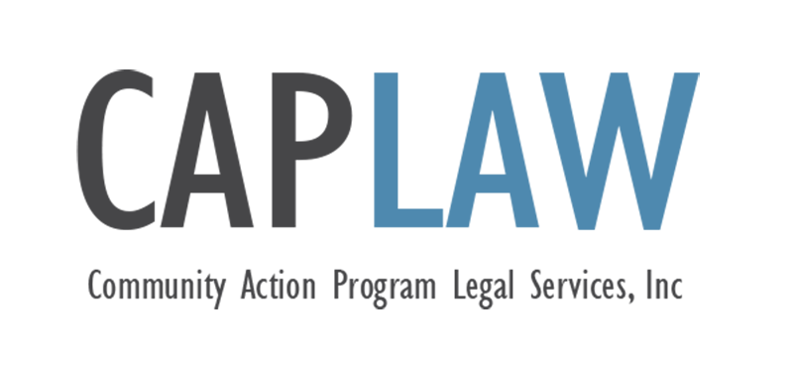
Religious Exemption Request – COVID-19 Vaccine
This sample form was developed by Community Action Program Legal Services, Inc. (“CAPLAW”) and has not been approved by any outside authority, such as the U.S. Department of Health and Human Services. When using this sample, CAPLAW strongly recommends you consult with counsel familiar with your CAA’s operations and the laws of your state.

This publication is part of the Community Services Block Grant (CSBG) Legal Training and Technical Assistance Center. It was created by CAPLAW in the performance of the U.S. Department of Health and Human Services, Administration for Children and Families, Office of Community Services Cooperative Agreement – Grant Award Number 90ET0467-03-C3. Any opinion, findings, conclusions, or recommendations expressed in this material are those of the author(s) and do not necessarily reflect the views of the U.S. Department of Health and Human Services, Administration for Children and Families.

The contents of this publication are intended to convey general information only and do not constitute legal advice. This publication does not constitute or create an attorney-client relationship. If you need legal advice, please contact CAPLAW or another attorney directly.

[Template] REQUEST FOR A RELIGIOUS EXEMPTION FROM THE COVID-19 VACCINATION REQUIREMENT
[CAA] policy requires [all CAA employees] to be vaccinated against COVID-19, with exceptions only as required by law. We are committed to respecting the important legal protections for religious liberty and providing equal employment opportunities for all in a workplace free from harassment, discrimination, and retaliation.
Requests for a religious accommodation will be evaluated and decided under Title VII of the Civil Rights Act (Title VII) [and any applicable state laws]. To be eligible for a possible exemption, you must first establish that your refusal to be vaccinated is based upon a sincere belief that is religious in nature.
To request a religious exemption, please complete this form and return it to [Human Resources]. We may request additional information and documentation to determine if you are legally entitled to an exemption. [Human Resources] will use the information provided to engage in an interactive process with you to determine whether you are eligible for an exemption/accommodation, and if a reasonable accommodation enables you to perform the essential functions of your position. During the interactive process, we encourage you to suggest specific accommodations that you believe would allow you to perform your job. However, [CAA] is not required to make any specific accommodation requested by you. We may provide an alternative accommodation, or we may deny an accommodation if it would impose an undue hardship on [CAA] or if there is a direct threat to the health and safety of [CAA] employees that cannot be mitigated by a reasonable accommodation.
Signing this form constitutes a declaration that the information you provide is complete and accurate to the best of your knowledge and ability. Any intentional misrepresentation to [CAA] may result in disciplinary action, including termination.

Part 1 – To Be Completed by the Employee
Request for COVID-19 Vaccine Exemption
Employee Name:
Date of Request:
Department:
Position:
Supervisor:
Phone Number:
- Please describe the nature of the religious beliefs that guide your objection to the COVID-19 vaccination requirement. Indicate how these beliefs conflict with the COVID-19 vaccination requirement. Documentation may be required to support your request.

- How long have you held the religious belief underlying your objection?

- If you do not have a religious objection to the use of all vaccines, please explain your objection to the COVID-19 vaccine.

- Please provide any additional information that you think may be helpful in reviewing your request.

I declare to the best of my knowledge and ability that the foregoing is complete and accurate.
Employee Name:
Employee Signature:
Date:

Part 2 – To be Completed by [Human Resources Staff]
Request for COVID-19 Vaccine Exemption
Employee Name:
Date Request Form Received:
Interactive Process Description (include dates of meetings/conversations, documentation provided by the employee, and descriptions of any accommodations discussed and why they were accepted or rejected):

Exemption/Accommodation granted? □ Yes □ No
Describe Exemption/Accommodation:

If exemption/accommodation granted, list required alternative safety precautions required:

If exemption/accommodation not granted, explain why:

Staff Name:
Staff Signature:
Date:

