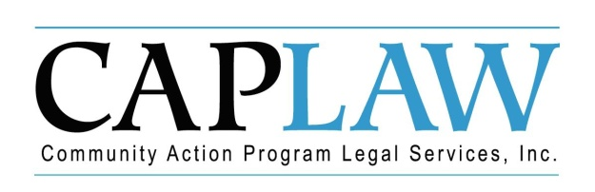

Introduction to and Tips when Presenting:
Board Roles & Responsibilities: Public Community Action Agencies

This tool was created in response to a need in the network for training and orientation materials that state Community Services Block Grant (CSBG) offices, state associations and individual Community Action Agencies (CAAs) can use to educate their own boards and staff that work with the board on the board’s vital role in the organization. This presentation is specifically for tripartite boards of public CAAs and acts as a guide for those training or orientating board members on the board’s responsibilities.

All of the slides include quizzes and scenarios and are all annotated in the notes section of the PowerPoint. The annotation provides the presenter with an understanding of the information that CAPLAW strives to convey when presenting on the topic addressed in the slide. The various ways we envision the Community Action network using the presentation include:

- Giving the presentation in its entirety;
- Presenting the slides in sections as noted on the webpage; and/or
- Augmenting an existing presentation with specific slides from this presentation.

The slides do not include all of the information that is important for tripartite boards to know. The slides are only intended to acknowledge and address the information that most tripartite boards will be tasked with overseeing. Every CAA is different and the way in which your CAA operates and the programs it runs will likely affect the information that is highlighted and included in a either an orientation or training on board roles and responsibilities.

Tips
Here are a few points to think about when working with the presentation:

- We intend for CAAs to use the PowerPoint in ways that will be most responsive to and effective for a particular CAA, state association or state CSBG office. Depending on the training and educational needs, the presenter may use all or some of the slides and may present the slides in an order that makes the most sense for the training. On the webpage, we make the slides available as a full presentation or via sections to help presenters recognize the flexibility we tried to build into this resource;

- For slides that include animation, the information in the notes section of the slide is intended to track that animation, i.e., when an image pops up on the slide the next section of text in the notes section should pertain to that image;

- The majority of animated slides are structured as to not reveal answers to quizzes or exercise on the slide until after the question has been read and, if so desired, discussed;

- If a copy of the slides is provided to the workshop participants in advance, the answers to the exercises and quizzes must be removed to avoid the participants from knowing the answers. We suggest to avoid disclosing the answers beforehand, save another version of the slides and, before converting the slides to a PDF for printing, remove the circles on the slides that designate the answers;

- Tweak/revise the slides and the note sections as needed to more accurately reflect your CAA and the way its board operates;

- CAPLAW prefers that you not credit us with the creation of the slides or source of the information; and

- Call/email CAPLAW with any questions regarding the content of the slides.

This training material was created in collaboration with Community Action Program Legal Services, Inc. (CAPLAW) and the Community Action Partnership (Partnership). This publication was created by National Association of Community Action Agencies - Community Action Partnership in the performance of the U.S. Department of Human Services, Administration for Children and Families, Office of Community Services Grant Number 90ET0465. Any opinion, findings, and conclusions, or recommendations expressed in this material are those of the authors and do not necessarily reflect the views of the U.S. Department of Health and Human Services, Administration for Children and Families.

